NATIONAL SCHOOL OF BUSINESS MANAGEMENT
BSc in Computer Science
CS402.3 Computer Graphics and Visualization
Duration: Three Hour

Question 1 (Image Processing Fundamentals)
- Name four image processing techniques.
- Name four applications of computer graphics
- Compare (look for similarities) and contrast (look for differences) image enhancement and image restoration.
- Take a look at the figure below about image processing. Identify and explain low, mid, and high-level technologies.
Mid-Level Process
Image Processing
Vision
Low-Level Process
High-Level Process
Image Analysis

Question 2 (Histograms)
- What is histogram of an image and explain the importance histogram equalization.
- Given an image (left 5x5 sub image) as below, derive the intensity mapping that will as best as possible equalize the image histogram. The image histogram is as shown on the right. There are 8 possible grey scale levels from 0 to 7.

  - Explain and illustrate the histogram equalization process.
  - Draw the equalized resulting 5x5 image.
Question 3 (Filtering and Transforming)
- What is noise in signal processing and briefly explain how it is added to an image?
- Name four filters and explain the filtering process with 3x3 kernel.
- Using a well-known transformation technique, explain how you can derive the lines from the following point cloud {(1,1), (2,1), (3,2), (4,1),(1,0)}.
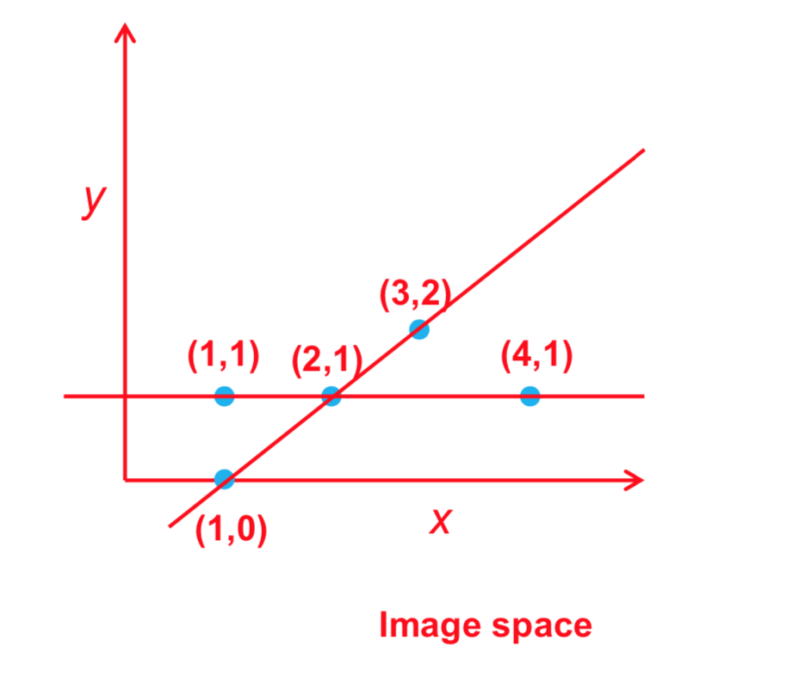
- Suppose you are given the following image with salt-and-pepper noise. Explain how you would recover/enhance the image. (4 marks)

?

Question 4 (Computer Graphics & Virtual Reality)
- Explain the following terms including the devises used in each and every technology.
  - Virtual Reality
  - Augmented Reality
- What are computer graphics?

Question 5 (Ray Tracing)
- What is Ray Tracing?
- List an advantage and a disadvantage of Ray Tracing?

Question 6 (Other)
- Explain the Canny edge detection technique.
- Explain why Python is so popular in image processing.
- What are the popular libraries related to image processing in Python?

